ER TO RELATIONAL SCHEMA

for

TOURISM MANAGEMENT SYSTEM

GROUP NO. 5

YASH SARANG

SHREYA SINGH

PARTH SURYAVANSHI

SURABHI TAMBE

Index. Pg.

1. Table creation using DDL commands 2

1. Creating tablespace, creating user, granting privileges to user
2. Creating destination table
3. Creating customer table 3
4. Creating package table
5. Creating tours table 4
6. Creating phoneno table

2. Inserting values using DML commands 5

1. Customer table
2. Destination table
3. Package table
4. Tours table
5. Phoneno table 6

\*\*\*\*\*\*\*\*\*\*\*\*\*\*\*\*\*\*\*\*\*\*\*\*\*\*\*\*\*\*\*\*\*\*\*\*\*\*\*\*\*\*\*\*\*\*\*\*\*\*\*\*\*\*\*\*\*\*\*\*\*\*\*\*\*\*\*\*

* Table creation using DDL commands:

1. Creating tablespace, creating a user, granting privileges to the user.

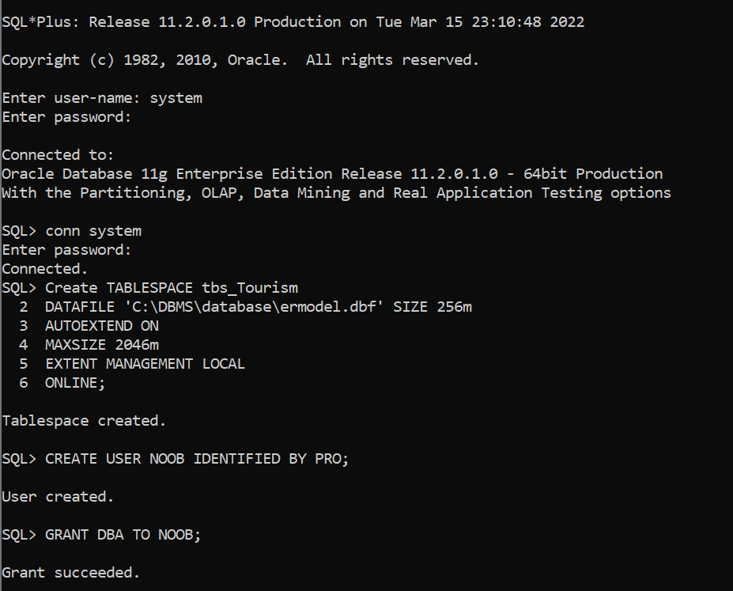

—---------------------------------------------------------------------

1. Creating destination table:

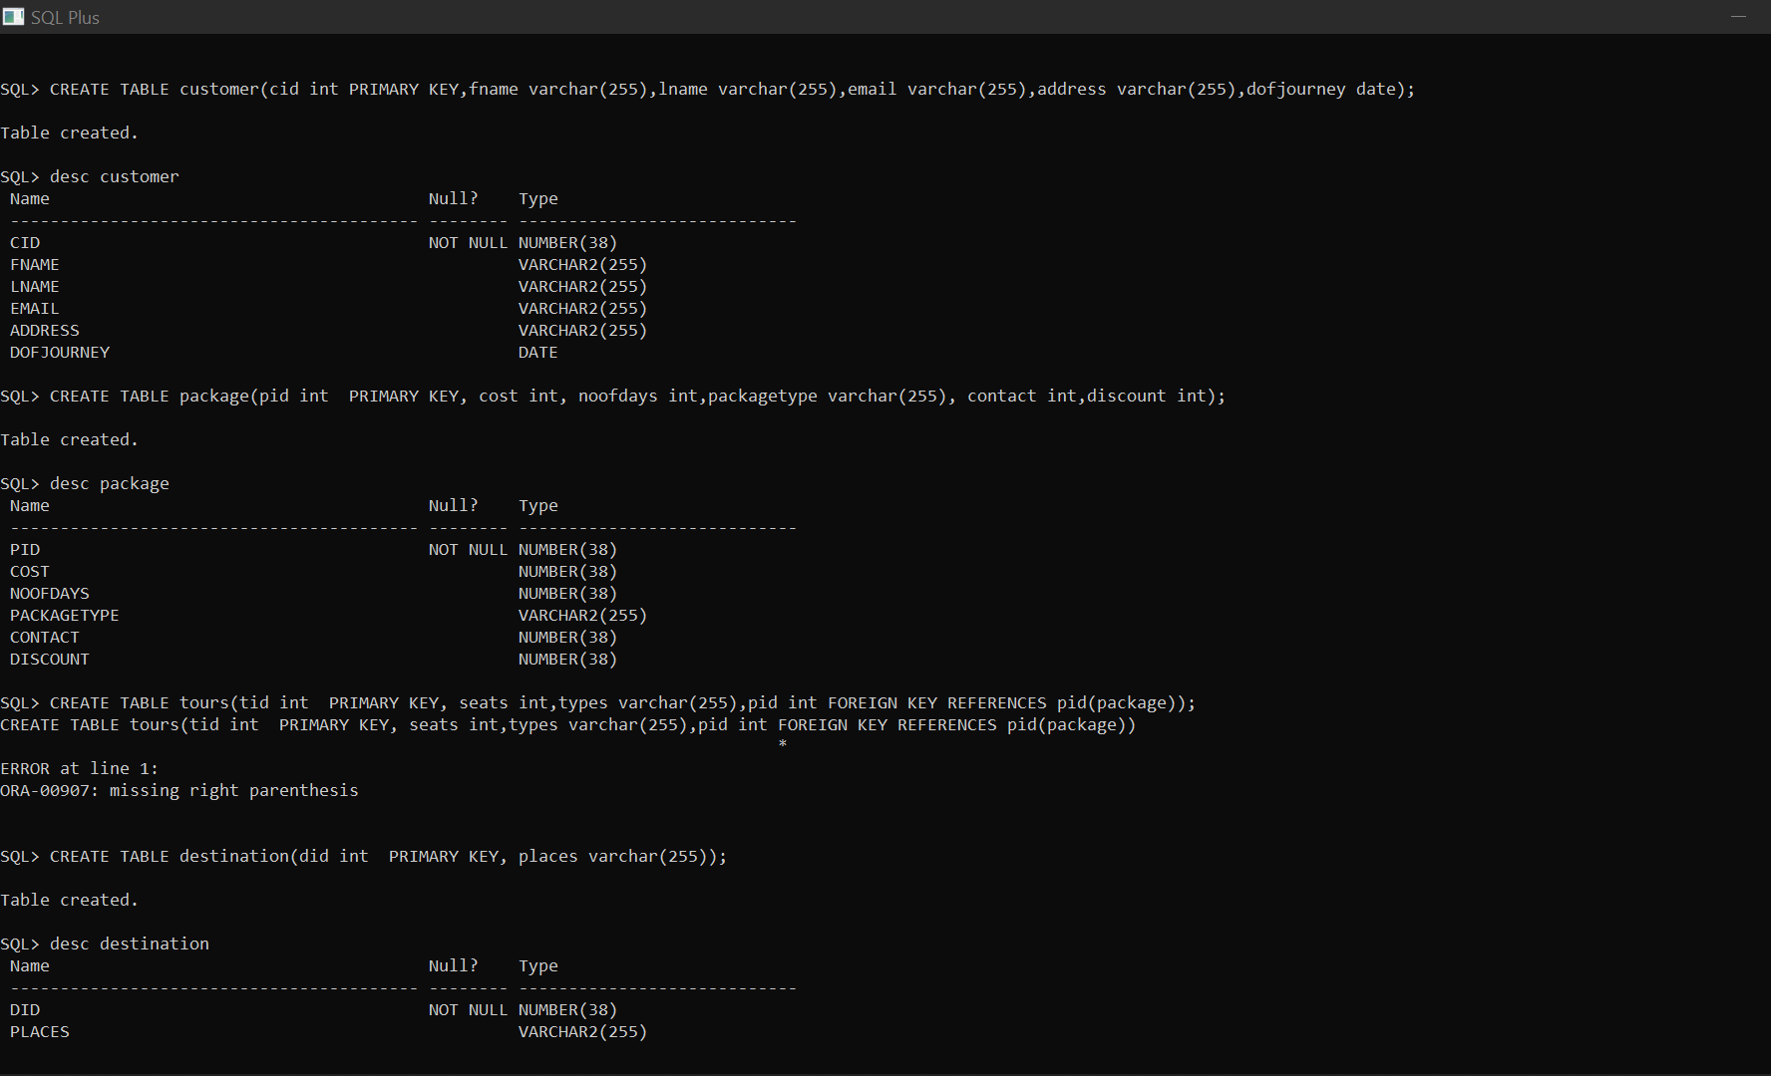

—---------------------------------------------------------------------

1. Creating customer table:

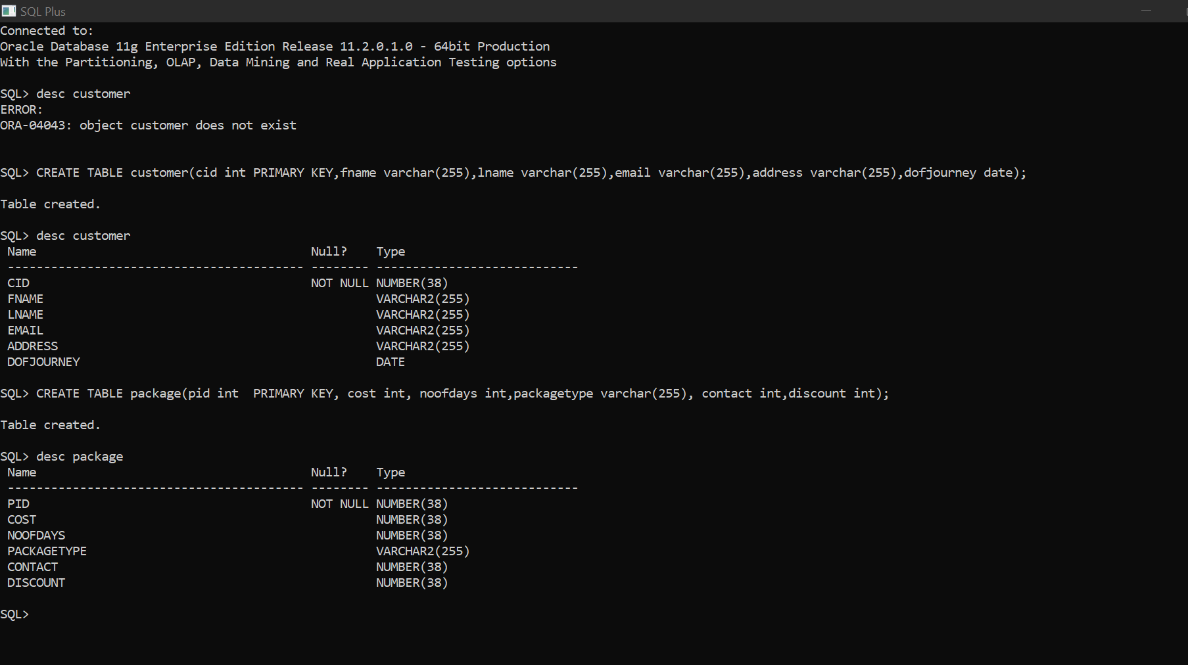

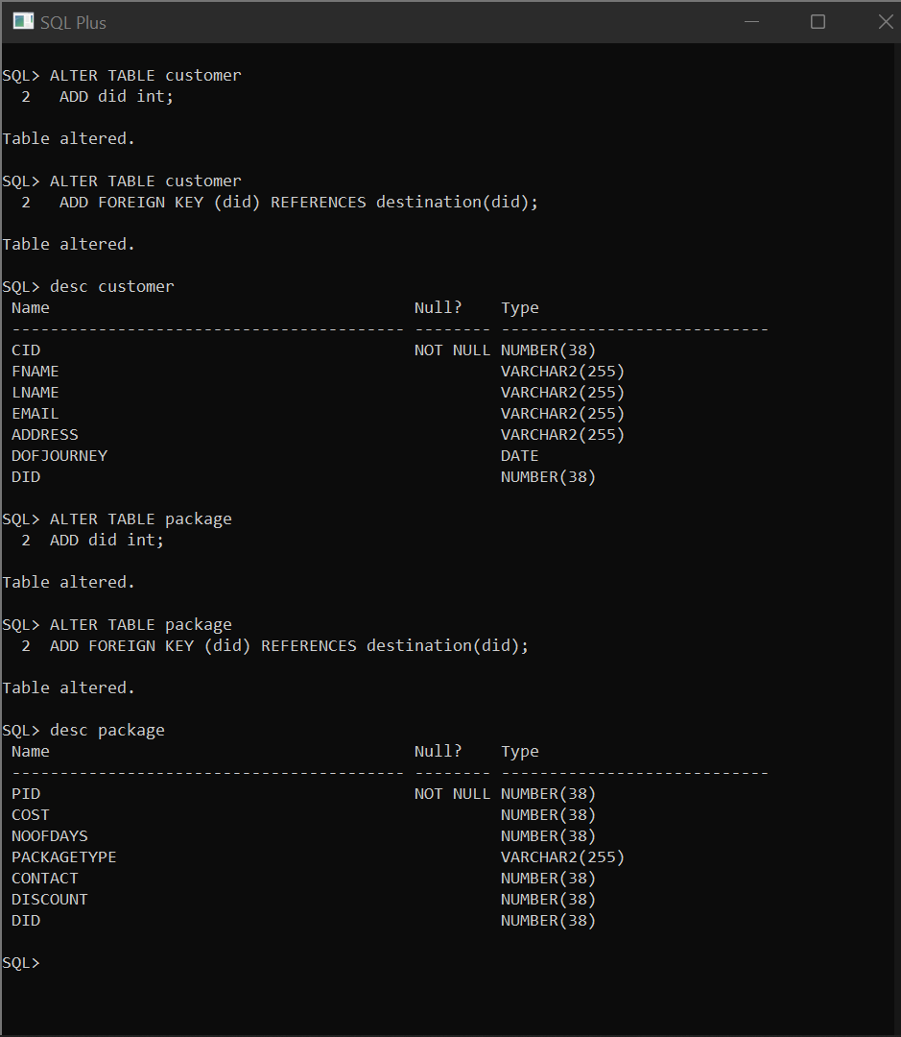

—---------------------------------------------------------------------

1. Creating package table:





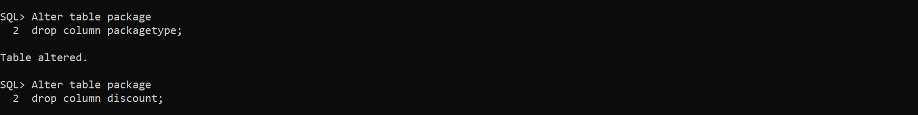

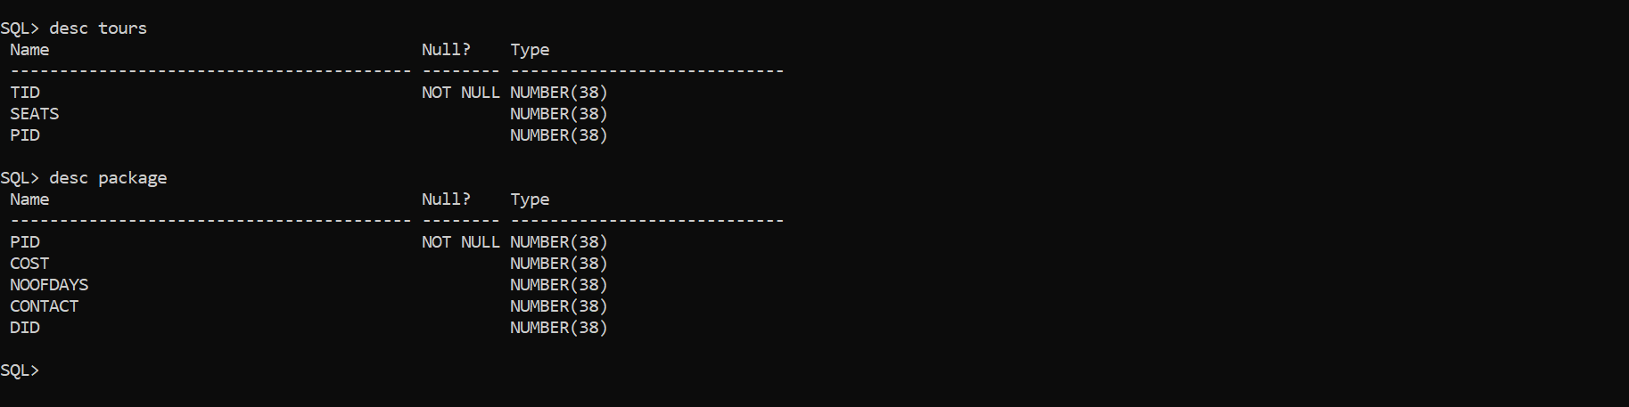

—---------------------------------------------------------------------

1. Creating tours table:

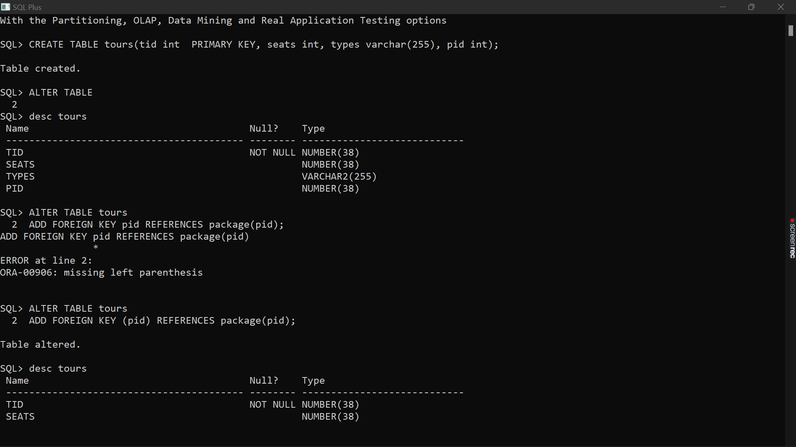



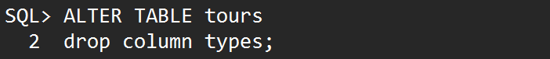 

—---------------------------------------------------------------------

1. Creating phoneno table:

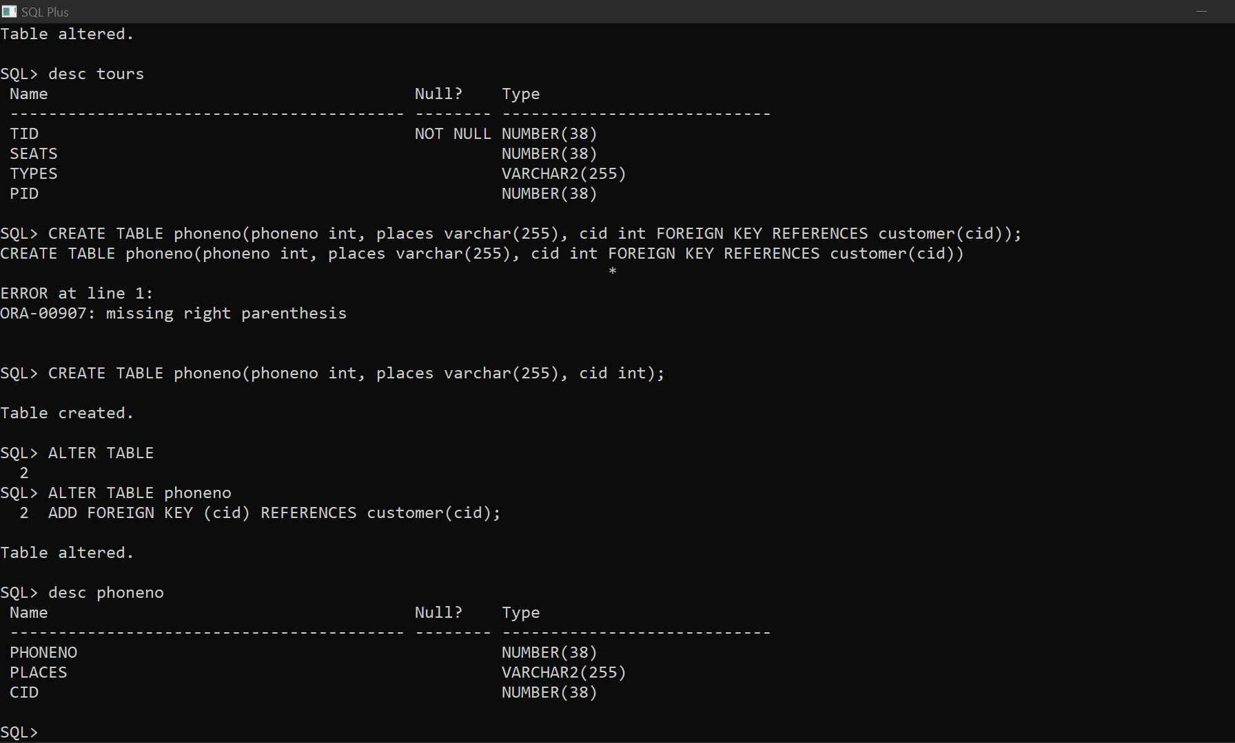



—---------------------------------------------------------------------

\*\*\*\*\*\*\*\*\*\*\*\*\*\*\*\*\*\*\*\*\*\*\*\*\*\*\*\*\*\*\*\*\*\*\*\*\*\*\*\*\*\*\*\*\*\*\*\*\*\*\*\*\*\*\*\*\*\*\*\*\*\*\*\*\*\*\*\*

* Inserting values using DML commands:

1. Customer table:

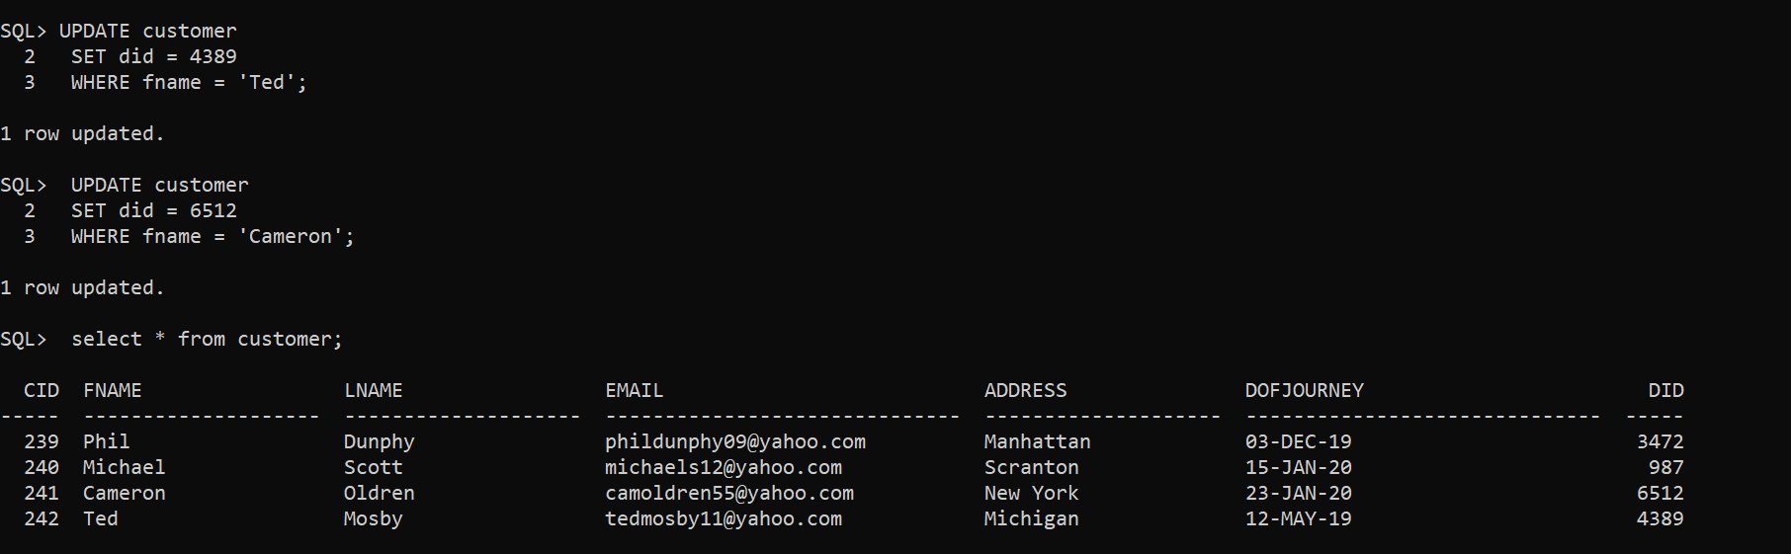

—---------------------------------------------------------------------

1. Destination table:

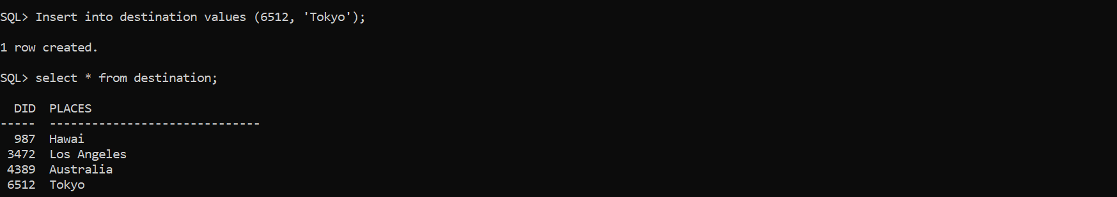

—---------------------------------------------------------------------

1. Package table:

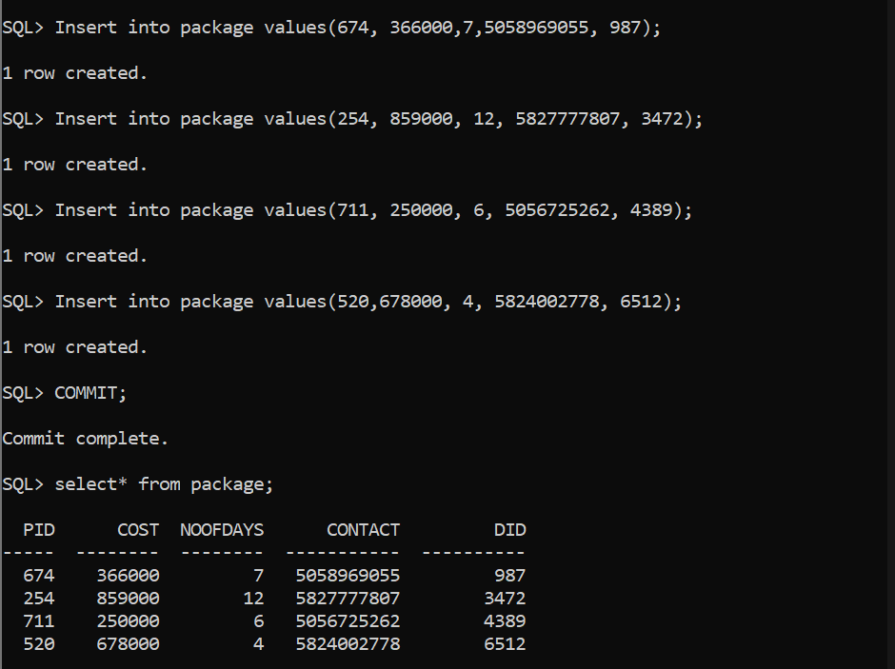

—---------------------------------------------------------------------

1. Tours table:

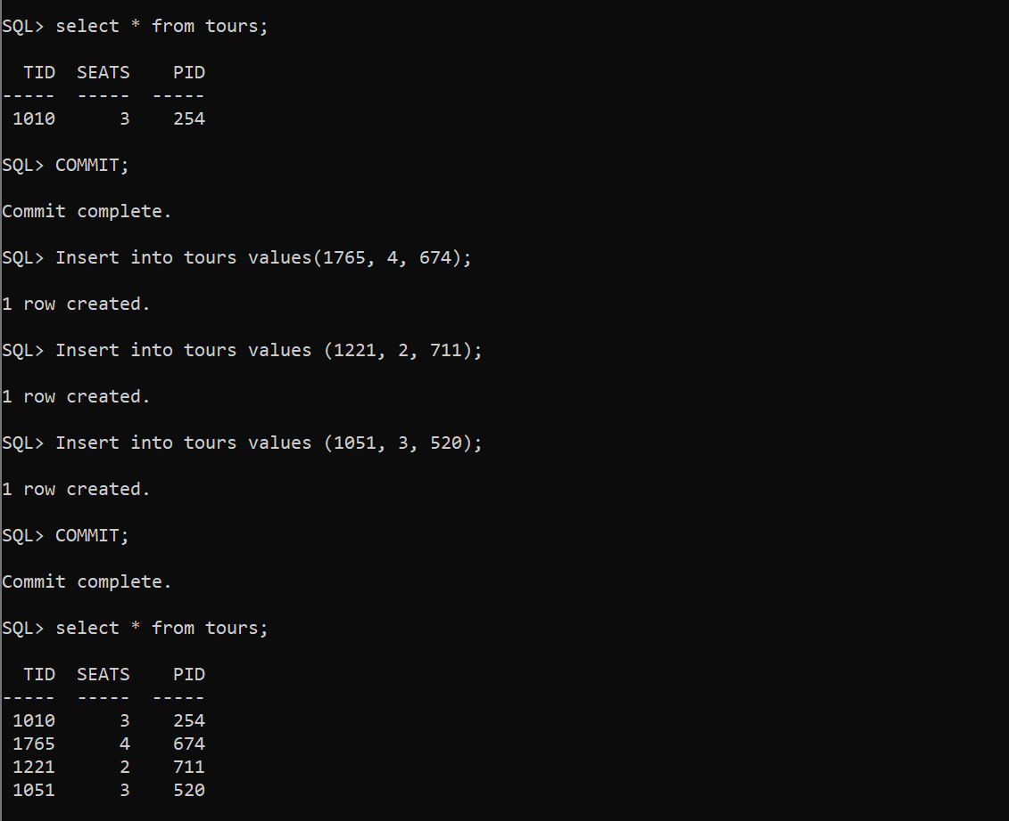

—---------------------------------------------------------------------

1. Phoneno table:



